**Checklist for migrating from External schemas to Managed schemas**

1. Need the External location where the managed schema can be created
   1. This is already done:
      1. For curated layer schemas, we would use abfss://rockwell@azradldaientdl<env>.dfs.core.windows.net/cur/<schema_name>
      2. For curated layer schemas, we would use abfss://rockwell@azradldaientdl<env>.dfs.core.windows.net/pro/<schema_name>
2. Need the privilege on the external location to create schemas to use as managed storage.
3. Script only would work for tables and views. Streaming tables, Materialized views and Functions should be manually dropped and recreated.
4. If there are foreign keys will have to be manually recreated.
5. Need privilege to rename the existing schema.
6. Managed volumes will not be migrated but external Volumes will be migrated.
7. Primary keys will be migrated but Foreign Keys will have to be created manually.

| Objects | Handled in Script | Comments |  |
| --- | --- | --- | --- |
| Delta tables  (External / Managed) | Yes |  |  |
| Non Delta external Tables | Yes | external tables will be dropped before recreated in the new schema |  |
| Functions | No | Need to migrate them manually |  |
| Views | Yes |  |  |
| Materialized views | No | Need to migrate manually |  |
| Streaming Tables | No | Need to migrate manually |  |
| Schema Level Grants | Yes |  |  |
| More granular grants | Yes |  |  |
| Managed volumes | No |  |  |
| External volumes | Yes | existing volume will be dropped and recreated in the target schema |  |

**How to Use the Script**

1. Run the script in the “Dry Run” field set to Y. Also provide the catalog name, schema name and the location which needs to be used as a managed location.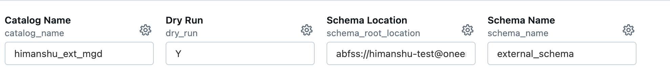
2. Script will capture and display all the inventory of objects and also generate the scripts that will be executed. Validate the output and the scripts.
3. Once validation is complete, set the “Dry Run” field to N and run all the cells. This time it will also execute the scripts and provide a before and after comparison of schema objects and data count.